Activity1: Logo Change in the browser extension
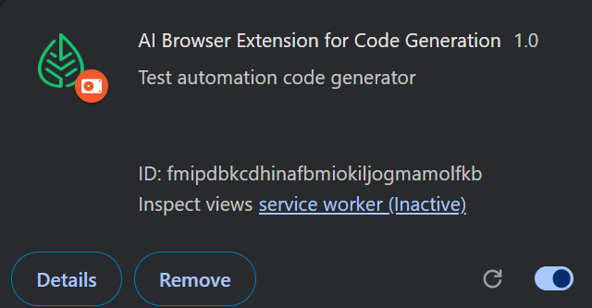

Activity2: New Open AI GPT model added
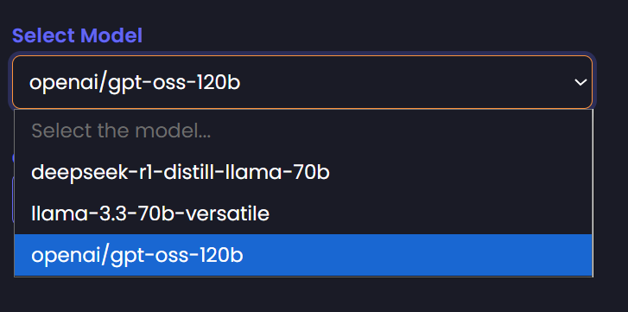

Activity3: Before Playwright with TS Support Implementation
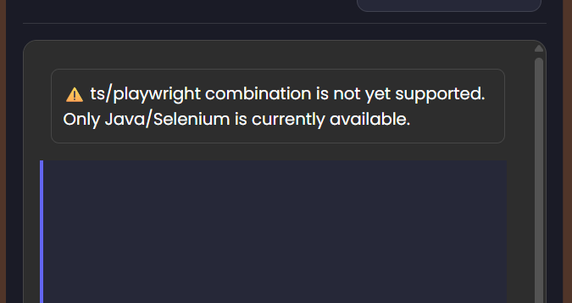

After Playwright with TS Support Implementation
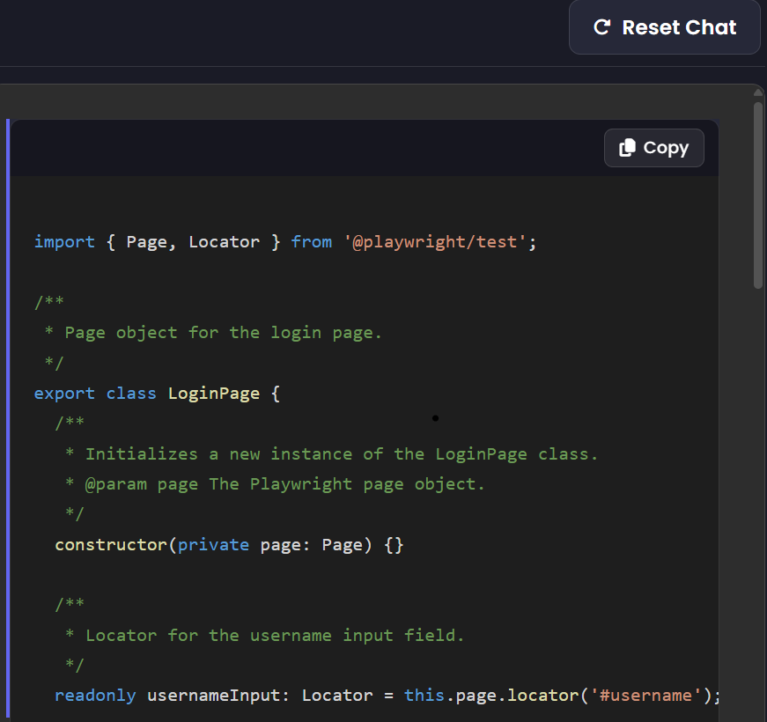

import { Page, Locator } from '@playwright/test';

/**
* Page object for the login page.
*/
export class LoginPage {
/**
* Initializes a new instance of the LoginPage class.
* @param page The Playwright page object.
*/
constructor(private page: Page) {}

/**
* Locator for the username input field.
*/
readonly usernameInput: Locator = this.page.locator('#username');

/**
* Locator for the password input field.
*/
readonly passwordInput: Locator = this.page.locator('#password');

/**
* Locator for the login submit button.
*/
readonly loginButton: Locator = this.page.locator('input[type="submit"]');

/**
* Navigates to the login page.
*/
async goto() {
await this.page.goto('https://leaftaps.com/opentaps/control/main');
}

/**
* Enters the username.
* @param username The username to enter.
*/
async enterUsername(username: string) {
await this.usernameInput.fill(username);
}

/**
* Enters the password.
* @param password The password to enter.
*/
async enterPassword(password: string) {
await this.passwordInput.fill(password);
}

/**
* Submits the login form.
*/
async submitLoginForm() {
await this.loginButton.click();
}

/**
* Performs a login with the given credentials.
* @param username The username to use.
* @param password The password to use.
*/
async login(username: string, password: string) {
await this.enterUsername(username);
await this.enterPassword(password);
await this.submitLoginForm();
}
}

